DATA UNDERSTANDING
Data Dictionary & Dataset Understanding Summary - Influencer Marketing ROI Analytics

1. Dataset Overview
The project draws on six linked Excel datasets covering the full path from campaign planning through to individual customer purchases. Together they span three dimension-style master tables (campaigns, influencers, products), one customer master table, and two fact-style tables capturing measured performance (influencer_campaign_performance and orders).
Dataset | Rows | Columns | Grain (1 row =) | Role
campaigns.xlsx | 10 | 10 | One marketing campaign | Campaign master / dimension
influencers.xlsx | 20 | 9 | One influencer/creator | Influencer master / dimension
influencer_campaign_performance.xlsx | 60 | 8 | One influencer x campaign pairing | Performance fact (ROI, cost, revenue)
orders.xlsx | 100,000 | 12 | One customer order line | Transaction fact
customer_demographics.xlsx | 90,000 | 11 | One customer | Customer master / dimension
products.xlsx | 25 | 7 | One product (SKU) | Product master / dimension

2. Dataset Relationships
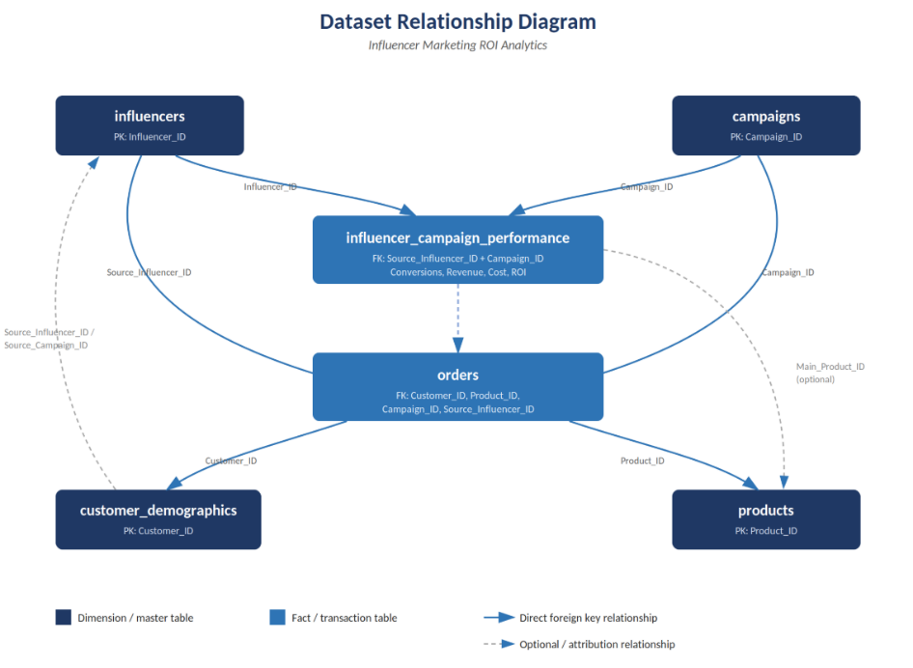

All six tables are connected through a consistent set of ID fields, forming a star-like structure with orders and influencer_campaign_performance as the two fact tables and campaigns, influencers, products, and customer_demographics as the surrounding dimension tables. Referential integrity was checked and confirmed clean - every foreign key value in orders and influencer_campaign_performance has a matching record in its parent table, with zero orphaned references.
From | Key | To | Relationship
orders | Customer_ID | customer_demographics | Many-to-one (many orders per customer)
orders | Product_ID | products | Many-to-one (many orders per product)
orders | Campaign_ID | campaigns | Many-to-one (many orders per campaign)
orders | Source_Influencer_ID | influencers | Many-to-one (many orders per influencer)
customer_demographics | Source_Influencer_ID / Source_Campaign_ID | influencers / campaigns | Many-to-one (acquisition source of each customer)
influencer_campaign_performance | Source_Influencer_ID + Campaign_ID | influencers + campaigns | Composite bridge (one row per influencer-campaign pair)
influencer_campaign_performance | Main_Product_ID | products | Many-to-one, optional (null when focus is Category/Collection, not a single SKU)

3. Dataset Contribution to the Business Problem
Each dataset plays a distinct role in answering the core question of whether influencer campaigns are generating measurable business value:
Dataset | Contribution to the Business Problem
campaigns | Defines what was actually planned - budget, platform, goal type, target audience, and timeline for every campaign. This is the denominator against which spend efficiency (ROI) is judged.
influencers | Profiles each creator's reach, tier, cost, and location match. Let’s the analysis test whether follower count and cost actually predict performance.
influencer_campaign_performance | The direct answer to "did this generate business value" - conversions, revenue, cost, and ROI at the influencer-campaign level. This is the core fact table for the ROI question.
orders | The transaction-level evidence behind every conversion - links each sale back to the customer, product, campaign, and influencer that drove it. Needed for revenue attribution, discount analysis, and channel comparison.
customer_demographics | Describes who was acquired through influencer campaigns - age, gender, income, location, lifetime value. Enables audience-fit and customer-quality analysis, not just raw conversion counts.
products | Supplies category, sub-category, price, and target gender/season for every SKU sold, enabling product- and category-level performance comparisons.

4. Data Dictionary
Field-level definitions, data types, and observed ranges for all six datasets are documented below.

4.1 campaigns.xlsx
Field | Type | Description | Notes / Range
Campaign_ID | Text (PK) | Unique campaign identifier | 10 unique, CMP001-CMP010
Product_Category | Text | Category the campaign promotes | 5 values: Jackets, Pants, Accessories, Dresses, Tops
Budget | Integer | Planned campaign budget (Rs) | 152,109 - 1,396,414
Goal_Type | Text | Primary campaign objective | Conversions or Awareness
Target_Gender | Text | Intended audience gender | Male, Female, Unisex
Product_Focus_Type | Text | Breadth of products promoted | Category, Collection, Single Product
Start_Date / End_Date | Date | Campaign flight window | May 2024 - Jun 2025
Conversion_Rate_Target_pct | Decimal | Target conversion rate (%) | 1.69% - 5.49%
Platform | Text | Platform the campaign ran on | Instagram, TikTok, YouTube

4.2 influencers.xlsx
Field | Type | Description | Notes / Range
Influencer_ID | Text (PK) | Unique influencer identifier | 20 unique, INF001-INF020
Name | Text | Influencer / handle name | 20 unique names
Gender | Text | Influencer gender | Female, Male, Unisex
Platform | Text | Primary platform | Instagram, TikTok, YouTube
Follower_Count | Integer | Total followers | 6,036 - 1,888,335
Tier | Text | Size tier | Nano, Micro, Macro, Mega
Location | Text | Influencer's base state | 13 Indian states
Avg_Cost_Per_Post | Integer | Average charge per sponsored post (Rs) | 300 - 40,000
Audience_Location_Match_pct | Decimal | % of audience matching brand's target region | 54.2% - 89.8%

4.3 influencer_campaign_performance.xlsx
Field | Type | Description | Notes / Range
Source_Influencer_ID | Text (FK) | Links to influencers.Influencer_ID | 16 of 20 influencers have performance records
Campaign_ID | Text (FK) | Links to campaigns.Campaign_ID | All 10 campaigns represented
Conversions | Integer | Conversions attributed to this influencer-campaign pair | 290 - 4,724
Revenue_Generated | Decimal | Revenue attributed (Rs) | Rs 1.15M - Rs 15.25M
Cost | Integer | Cost paid to influencer for this campaign (Rs) | 900 - 120,000
ROI | Decimal | Return on investment(Revenue-Cost)/Cost x100 | 57.2% - 1,439.3%
Product_Focus_Type | Text | Focus type for this specific pairing | Category, Collection, Single Product
Main_Product_ID | Text (FK) | Links to products,Product_ID | 36 of 60 rows null - null whenever focus is not "Single Product" (structural, not missing data)

4.4 orders.xlsx
Field | Type | Description | Notes / Range
Order_ID | Text (PK) | Unique order identifier | 100,000 unique
Order_Date | Date | Date the order was placed | Jan 2024 - Sep 2025
Customer_ID | Text (FK) | Links to customer_demographics | 90,000 unique customers
Product_ID | Text (FK) | Links to products.Product_ID | All 25 products represented
Quantity | Integer | Units ordered | 1 - 4
Unit_Price | Integer | Price per unit at time of order (Rs) | 608 - 8,526
Discount_Code_Used | Text | Influencer-branded discount code applied | 16 unique codes, format INFxxxCODE
Discount_Amount | Decimal | Discount value applied (Rs) | 0.01 - 3,889.50
Source_Influencer_ID | Text (FK) | Influencer credited with the sale | Links to influencers.Influencer_ID
Campaign_ID | Text (FK) | Campaign credited with the sale | Links to campaigns.Campaign_ID
Total_Amount | Decimal | Final order value (Rs) | = Quantity x Unit_Price - Discount_Amount (verified, 0 mismatches)
Channel | Text | Platform the order came through | Instagram (66%), YouTube (21%), TikTok (13%)

4.5 customer_demographics.xlsx
Field | Type | Description | Notes / Range
Customer_ID | Text (PK) | Unique customer identifier | 90,000 unique
Gender | Text | Customer gender | Male, Female, Other
Age | Integer | Customer age (years) | 18 - 60
Location | Text | Customer's state | 20 Indian states
Income_Bracket | Text | Income segment | Low, Medium, High
Preferred_Style | Text | Fashion style preference | 6 values: Casual, Boho, Streetwear, Athleisure, Formal, Luxury
Source_Influencer_ID | Text (FK) | Influencer that acquired this customer | Links to influencers.Influencer_ID
Source_Campaign_ID | Text (FK) | Campaign that acquired this customer | Links to campaigns.Campaign_ID
Is_New_Customer | Boolean | First-time buyer flag | True / False
Lifetime_Value | Decimal | Total customer lifetime value (Rs) | 516.81 - 43,256.22
Avg_Order_Value | Decimal | Average order value (Rs) | 516.81 - 24,962.28

4.6 products.xlsx
Field | Type | Description | Notes / Range
Product_ID | Text (PK) | Unique product/SKU identifier | 25 unique, PRD001-PRD025
Category | Text | Product category | 5 values: Accessories, Dresses, Jackets, Pants, Tops
Sub_Category | Text | Material/sub-category | Cotton, Denim, Silk, Leather, Polyester
Price | Integer | List price (Rs) | 608 - 8,526
Gender_Target | Text | Intended gender | Male, Female, Unisex
Season | Text | Seasonal relevance | All-Season, Winter, Summer
Launch_Date | Date | Product launch date | Sep 2022 - Aug 2025

5. Analytical Dimensions
The following dimensions are available across the dataset to slice and filter the KPIs below, and will form the filter set for the executive dashboard:
Dimension | Available Cuts
Platform | Instagram, TikTok, YouTube - present in campaigns, influencers, and orders
Influencer / Tier | 20 named influencers; Nano / Micro / Macro / Mega tiers
Campaign | 10 campaigns, each with Goal_Type (Conversions/Awareness) and Product_Focus_Type
Time | Order_Date, campaign Start/End_Date, product Launch_Date - supports monthly/seasonal trend views
Product / Category | 5 product categories, 5 sub-categories, 25 SKUs
Customer segment | Gender, Age, Income_Bracket, Preferred_Style, Location, New vs. Returning
Geography | Influencer location (13 states) and customer location (20 states)

6. Key KPIs
These KPIs, derivable from the existing fields, will anchor the EDA and dashboard stages of the project:
KPI | Formula | Purpose
ROI % | (Revenue_Generated - Cost) / Cost x 100 | Core profitability measure per influencer/campaign
Cost per Conversion | Cost / Conversions | Efficiency of spend at driving sales
Revenue Efficiency by Influencer Size | Revenue_Generated / Follower_Count | Tests whether bigger audiences convert proportionally
Conversion Rate (Actual) | Conversions / Estimated Reach or Orders | Compare against Conversion_Rate_Target_pct
Average Order Value (AOV) | Total_Amount / number of orders | Order-level revenue benchmark, by influencer/campaign/channel
Customer Lifetime Value (CLV) by source | Avg(Lifetime_Value) grouped by Source_Influencer_ID | Value of customers acquired per influencer, beyond first sale
Discount Rate | Discount_Amount / (Unit_Price x Quantity) | How much margin is given up per influencer code
New Customer Rate | Count(Is_New_Customer=True) / Total customers, by source | Measures acquisition vs. repeat-purchase impact of a campaign

7. Dataset Understanding Summary
The dataset is a coherent, well-structured relational set covering campaign planning (campaigns), influencer profiles (influencers), attributed performance (influencer_campaign_performance), and Actual customer transactions (orders, customer_demographics, products). Referential integrity is intact across all six tables, and the only structural null pattern (Main_Product_ID in influencer_campaign_performance) is explainable by business logic rather than a data quality defect.
Two limitations are worth flagging for the Data Quality Assessment stage: (1) four influencers (INF011, INF013, INF015, INF018) appear in the influencer master table but have no orders or performance records, meaning they ran no tracked campaigns in this window; and (2) the dataset does not include post-level engagement metrics such as impressions, clicks, likes, or comments, so "engagement" and "fake engagement detection" in the original brief will need to be approximated using ROI and cost-efficiency outliers rather than true engagement data. Both points will be carried into the Data Quality Assessment report.

